Oracle

## Screening round:

Technical: I have an array of building heights [5,4,3,6,1] ocean is on the right side. Tell me all buildings that have “some” floors with an ocean view.

Soln: Come from the end of array, maintain current max, if height at i is > current max that has the view and update the current max, push the i into array. In the end reverse the array and send

Technical: Find the first unique number in a 1-indexed array

Soln: bruteforce was okay. Just had to put things in a set and go through the array twice in effect.

Behavioural: I forgot the question. But was able to relate from history in BB

## 

## Loop round 1:

See below images

Behavioural:

Explain a situation where u had disagreements with external customer and tell me what u did to solve that

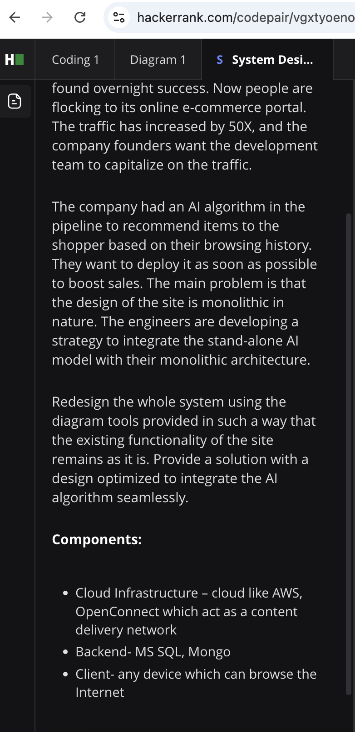

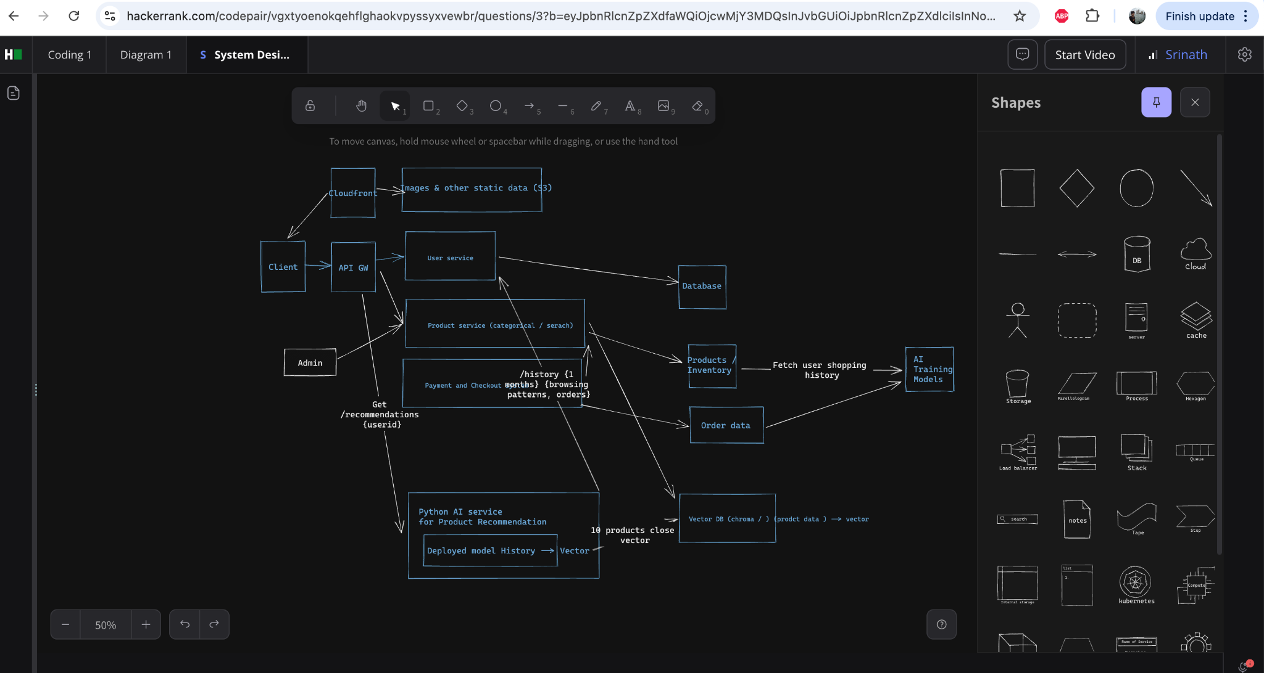

Additional:

1. How do u scale this
2. How do u debug issues in this
3. Where all are u going to cache things
4. What all are u monitoring
5. TPS based autoscaling vs HPA
6. Scaling / Capacity in general

## Loop round 2:

System design

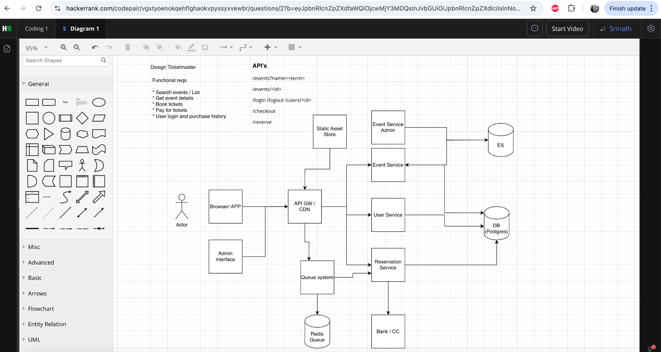

Coding:

Tell me in a array of building heights 4,2,3,1 <ocean> which all index has ocean view

Behavioural:

An incident where I got bad review

## Loop3:

Waste fellow. Used chatgpt to ask questions. Nothing interesting, just on kubernetes scenarios on how to solve Pending / Crashloopbackoff etc

## Loop 4:

An independent outside person (of the org).

Not a system design kind technical round, but more on architectural choices, reasoning behind the choices at whatever depth he feels like.

Behavioural: Push back, Cut scope type things

## Loop 5:

Director level person. Mostly on my experience with Ci/CD SRE best practices. Not too technical. But more behavioural

Like

Tell me your proudest moment etc

What do you do when you see a Node is having issues in kubernetes

Canonical

Round 1: Written interview → <https://github.com/srinathhs/resume/blob/main/canonical-written-test.pdf>

Round 2: DevSkiller (dependent on the role applied)

MCQ on Docker, kubernetes, Html, Rest etc. (Open book)

One javascript problem to implement polish notation calculator (openbook again)

Round 3: Psychometric test

Failed psychometric on visual / form ground as usual.

Amazon Sr SOl Architect

Round 1:

1. How do you scale a three tire architecture
2. How do I scale a database - Was expecting me to magically tell him that I will move the DB to dynamodb, skipping all the steps in between.

Juspay

Round 1:

Junior fellow.

What is was supposed to be:

It will be an overall discussion to understand about your work experience and different projects that you have worked upon, Also discussion on Systems related concepts, Infra, devops, sre monitoring, etc

WHat it was:

The discussion was mostly cryptography, quantum computing, database hashing/ index design and reliability, datacenter stuff and mathematics.

Round 2:

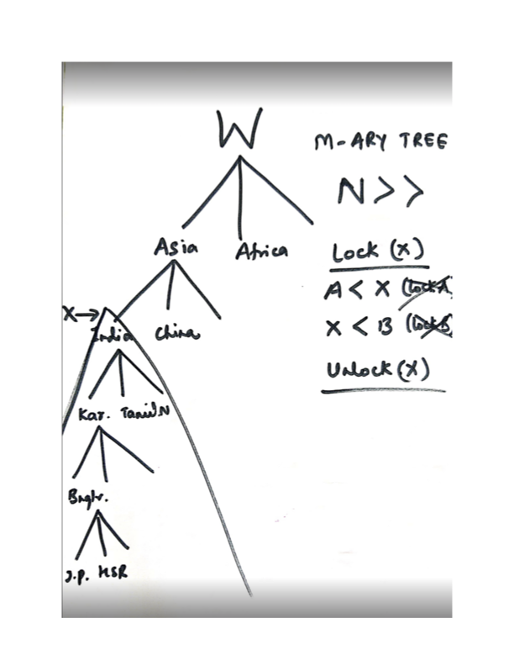

Lock (x) Is basically a level below which next request to lock will be blocked and return false

But if there is a lock already on the path (above or below) then u cannot lock, means

If while traversing I encounter a lock

if : Any descendent of X is locked then we cannot lock it : return false

Create the data structure as in the diagram

N nodes with M childs max

N could be large

Optimise the worst case time complexity by not visiting all nodes.

After this he asked me to assume all operations as atomic and implement multithreading without locking the tree. There is no answer to that one. The person wanted an answer, the interview had gone on form 11AM till 11PM. I quit.

Amazon Gen ai sol architect

## Screening round:

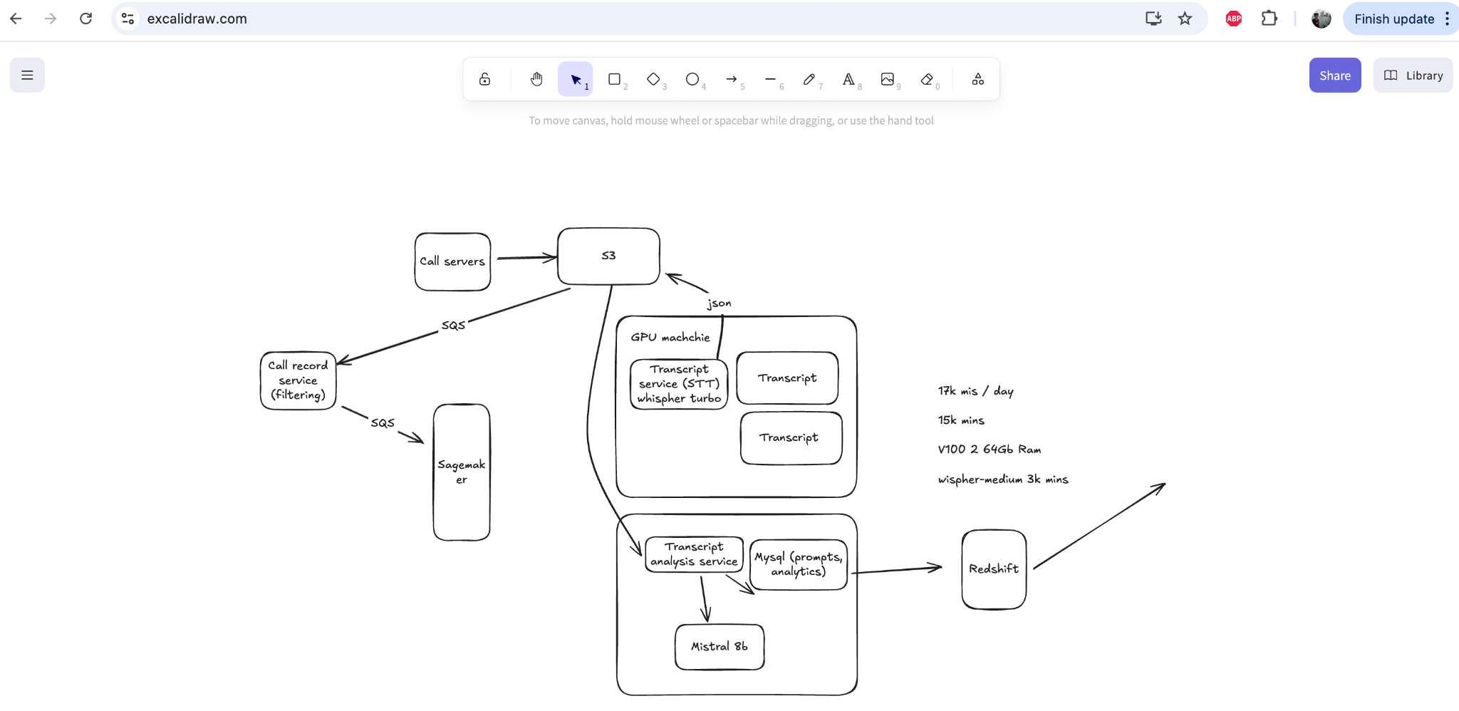

1. Explain about yourself
2. Explain the calloptix flow completely
   1. Scaling
   2. Provisioning for future
   3. Metrics etc
3. prompt injection avoidance
4. LLM selection, Sagemaker tools, Hallucination prevention, RAG model workflow, when you would use RAG vs LLM vs agents, what are agents when would u use that, temperature/topk of a model
5. Any other LLM based work I have done etc

